**Rwanda Report**

To understand the Energy Access in Rwanda the financial and technical support of three organizations were needed: The Energy Sector Management Assistance Program (ESMAP), The World Bank and initiative Sustainable Energy for All (SEorALL).  
  
Based on the Multi – Tier Framework (MTF) , the survey was run in 2016 into five provinces of Rwanda with the goal to collect information about the access of electricity in the country. A total of 3,300 households were covered in urban and rural areas.

**Method**

The MTF considers any technology (including fuel based electricity supply), attributes, tiers and use of electricity to evaluate the energy access in a country. These detailed energy data enable governments and other stakeholders with a holistic view of the energy challenges for policy design or implementations.

Seven attributes are related to evaluate the electricity access: Capacity, Reliability, Affordability, Health & Safety, Availability, Quality and Formality. The aim of this attributes is to reflect the energy supply and the user experience related to it. All of the seven attributes have their own focus of information and specific questions in the general survey.

**Attributes and Tiers**  
  
1. Capacity: To know what appliances the household can power.

2. Availability: To know if the power is available to the household when it is needed.

3. Reliability: To know if the electric service is frequently interrupted.

4. Quality: To know if the voltage fluctuations of the electricity access can damage the household appliances.

5. Affordability: To know if the household income can afford to purchase the minimum amount of electricity.

6. Formality: To know is the service is a formal or informal provider.

7. Health and Safety: To know if it is safe to use the electricity services or if there were any risk injuries from using the service.

Each attribute has a tier from 0 to 5. Meaning that tier 0 is no access at all and tier 5 full access. The variables that measure the tiers change depending on the attributes. The following graph shows the MTF for electricity supply.

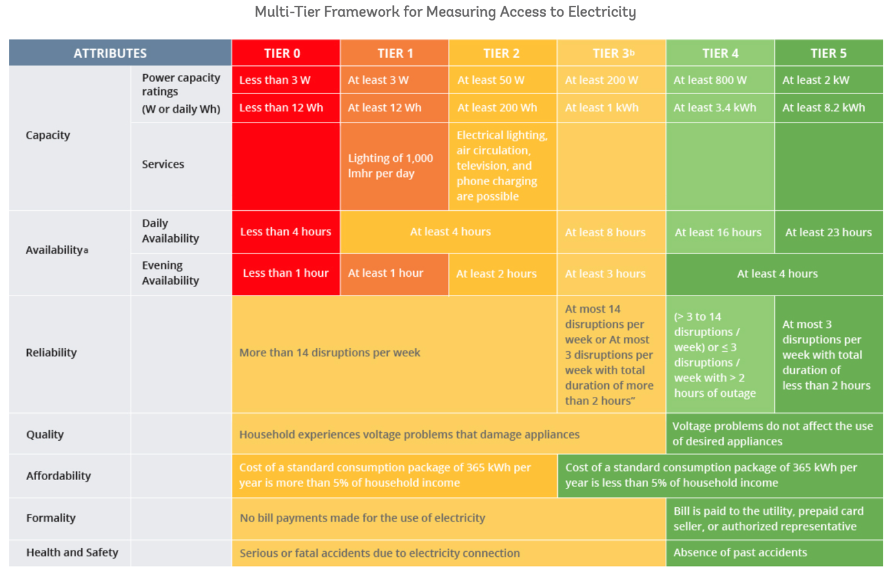

 Source: Energy Sector Management Assistance Program. Beyond Connections. Energy Access Redefined. Technical Report 008/15.July 2015

**Results**

After collecting the data for each attribute and categorized them in a specific tier some conclusions were discover:

**1.**     **Capacity:**73.2% of households are on tier 0, this means that they do not have access to any electricity source or the power capacity is less than 3 W. Meanwhile, 10.3% of households are on Tier 3, just having at least 200 W of power capacity.

**2.**     **Availability:** 49.6% of the household receive more than 22 hours of electricity and 5.9% of the household receive less than 4 hours. The electricity in the evening (4 hours) has a major coverage – 72% of the households.

**3.**     **Reliability:** The disruptions of energy supply from 4 to 14 interruptions is the most prominent problem in the majority of the households – 68.4% of the households. This means that most of the population Nationwide is on Tier 3.

**4.**     **Quality:** 20.9% of the voltage electricity supply is low, meaning that most appliances in the household could not work or end damaged.

**5.**     **Formality**: 98.3% of the household have a formal grid connection and just 1.7% of informal grid connection. For this attribute, the MTF inferred information from indirect questions that the respondent were willing to answer.

**6.**     **Affordability:**The attribute couldn’t be calculated. The survey was not able to collect expenditure data.

**7.**     **Health and Safety:** Nationwide, 95,3% of the grid connection in the household didn’t have a serious accident.